**[8] OOP’s in CPP –**

1) Classes & Object basic Intro -

1.1) Access Modifiers

1.2) Getters & Setters -

2) Encapsulations -

2.1) This Constrcutor

2.2) Types of Cosntrcutrs -

2.3) Copy Constructor Conceppt -

2.4) Shallo & Deep Copy -

3) Destructor -

4) Inheritance -

4.1) Mode of Inharitance -

4.2) types of Inheritance -

4.2.1) Single Inheritance -

4.2.2) Multi-Level Inheritance -

4.2.3) Multiple Inheritance -

4.2.4) Hierarchical Inheritance -

4.2.5) Hybrid Inheroitance -

5) Polymorphism -

5.1) Compiletime Polymorphism -

5.1.1) Function Overloading -

5.1.2) Function Overloading -

5.2)Polymorphism -

5.2.1)Function Overriding -

5.2.2)Virtual Functions –

6) Abstraction - 7) Static Keyword - 8) Friend Class & Friend Function –

**8) OOP’s in CPP –**

**//1) Classes & Object basic Intro - 01**

**//4) Inheritance - 25**

**//5) Polymorphism - 47**

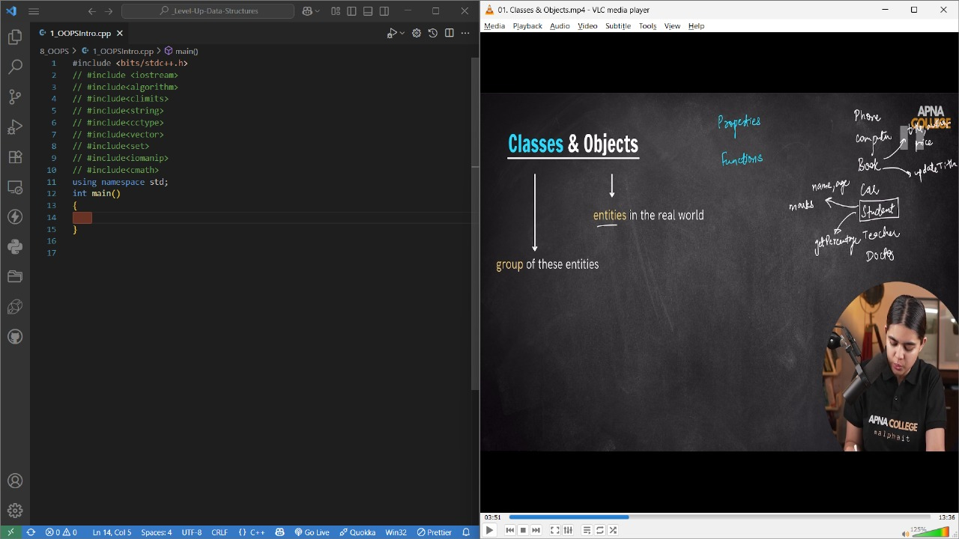

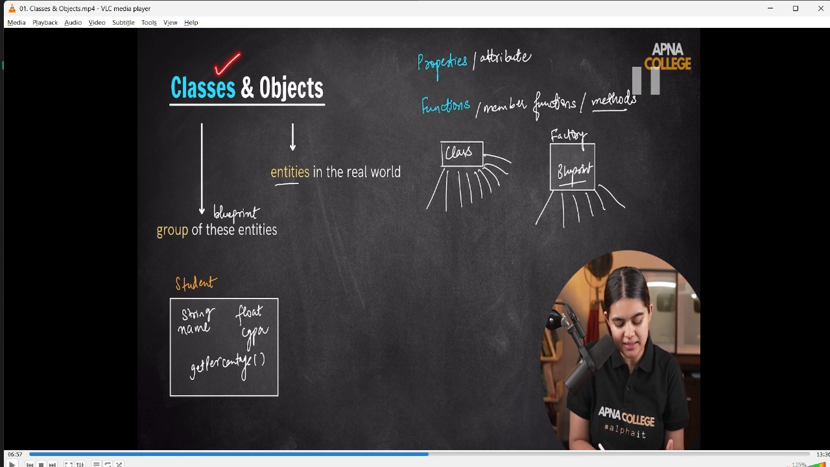

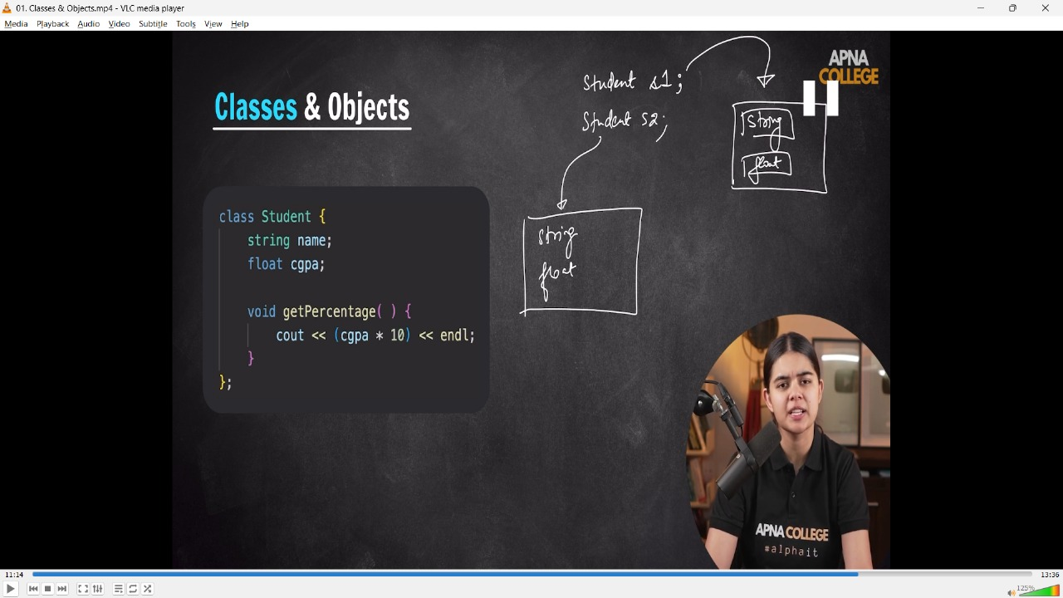

// class User

// {

//     int id;

//     string username;

//     string password;

//     string bio;

//     string profilephoto;

//     void deactivate()

//     {

//         cout << "Do you rally wnatt to delete your account" << endl;

//     }

//     void editBio(string newBio)

//     {

//         bio = newBio;

//         cout << "Bio updated successfully" << endl;

//     }

//     void changeProfile(string newprofile)

//     {

//         profilephoto = newprofile;

//         cout << "You got a new profile" << endl;

//     }

// };

// int main()

// {

//     User first;

// }

// -------------------

**// AccessModifiers**

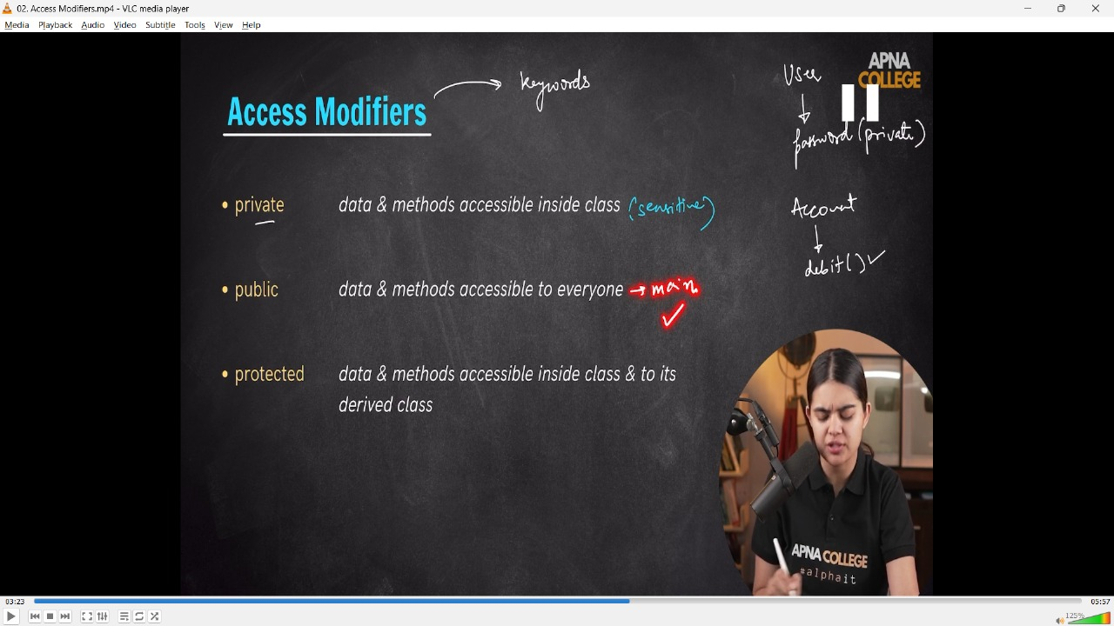

**//1.2) Getters & Setters -**

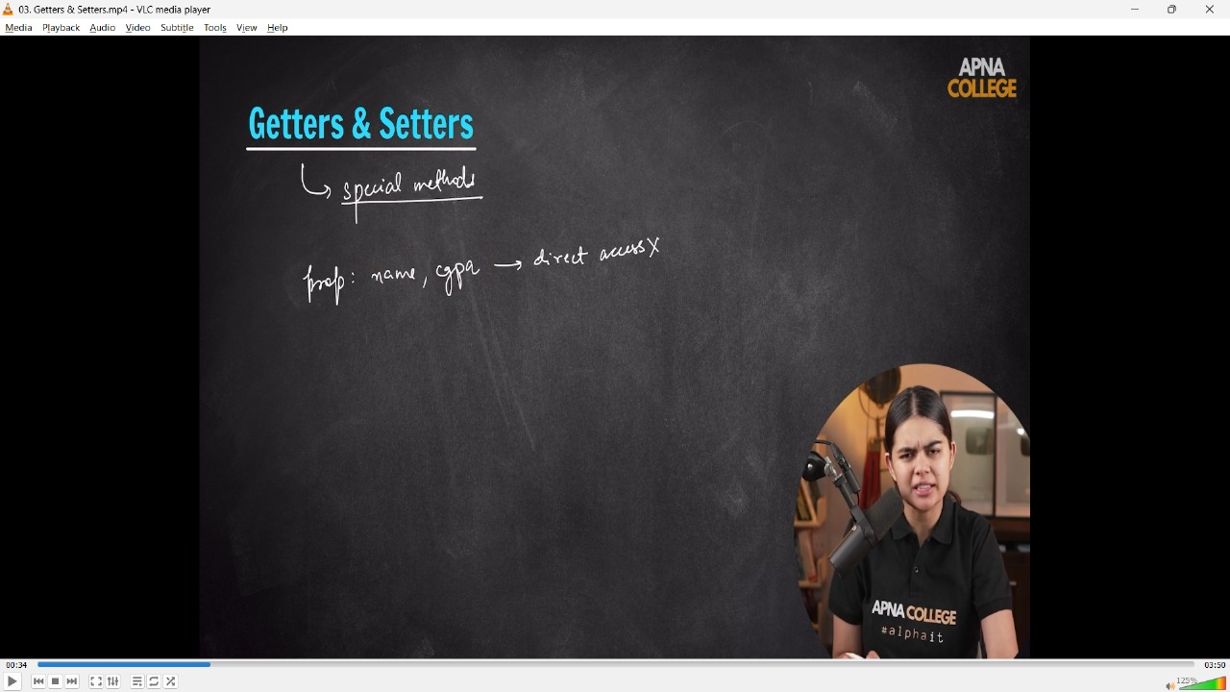

// class Student

// {

//     string name;

//     float cgpa;

// public:

//     void getPercentage()

//     {

//         cout << (cgpa * 10) << endl;

//     }

//     // Setters  - basicly uses when don;t have direct acess to the Private elements of class but can be modified throug setters

//     void setName(string nameval)

//     {

//         name = nameval;

//     }

//     void setCgpa(float cgpaval)

//     {

//         cgpa = cgpaval;

//     }

//     // Getters - the vakue which we set through setter can be accesed through getters, as can;t access to the pvt class, so cna be done byu thios Getter,Setters

//     string getName()

//     {

//         return name;

//     }

//     float getCgpa()

//     {

//         return cgpa;

//     }

// };

// int main()

// {

//     Student s1;

//     s1.setName("Shubham");

//     s1.setCgpa(7.55);

//     cout<<s1.getName()<<endl;//Shubham

//     cout<<s1.getCgpa()<<endl;//7.55

// }

// -------------------

**2) Encapsulations -**

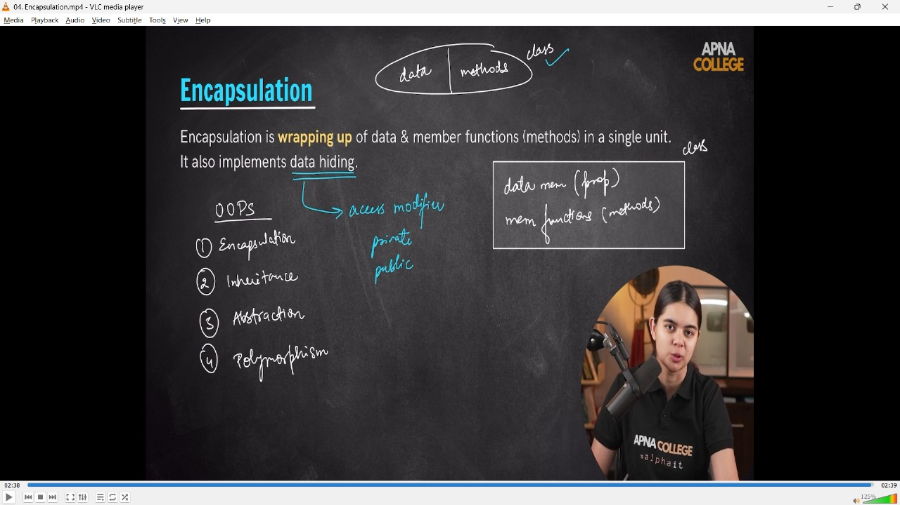

//2) Encapsulations - EK single unit me data & memeber Functions ko implement krna. Matlab data member(property)  & memeber function(methods)

// Abstraction - Constructor automatically create ho jaata h object creatin ke tym pr

// class Car

// {

//     string name;

//     string color;

// public:

//     Car(string nameValue, string colorvalue)

//     {

//         cout << "Constructor is called object being created----" << endl;

//         name = nameValue;

//         color = colorvalue;

//     }

// public:

//     void start()

//     {

//         cout << "Car has started.." << endl;

//     }

//     void stop()

//     {

//         cout << "Car has been stopped.." << endl;

//     }

//     // Getter

//     string getName()

//     {

//         return name;

//     }

// };

// int main()

// {

//     // Car c1;//// Constructor is called object being created----

//     Car c1("Altroz", "Black");

//     cout << "Car name : " << c1.getName() << endl; // Car name : Altroz

// }

// -------------------

**//2.1) This Constrcutor**

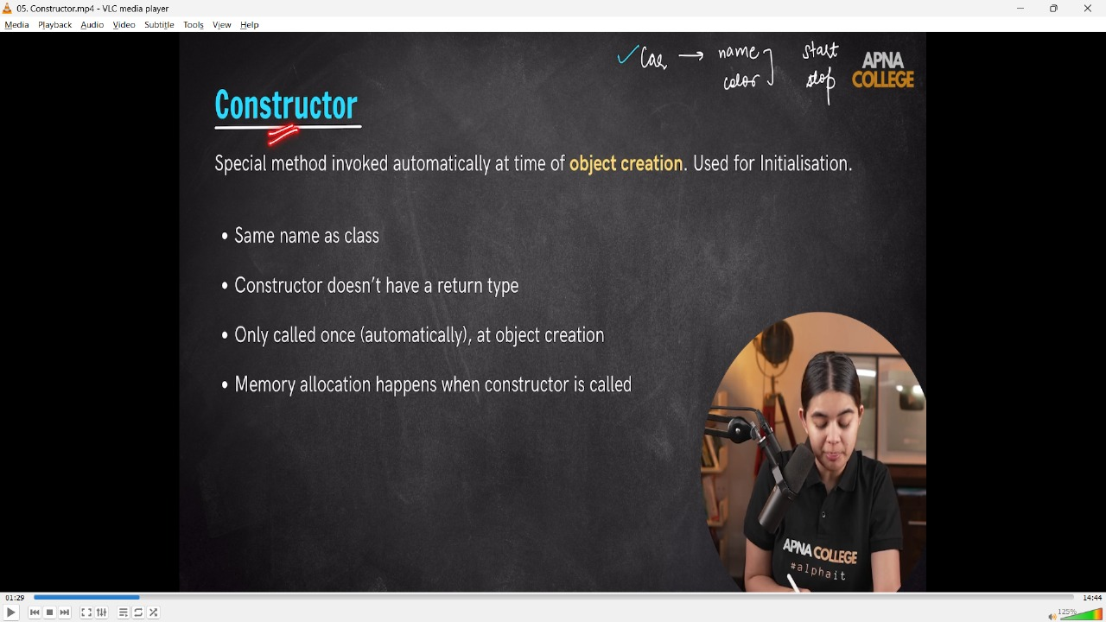

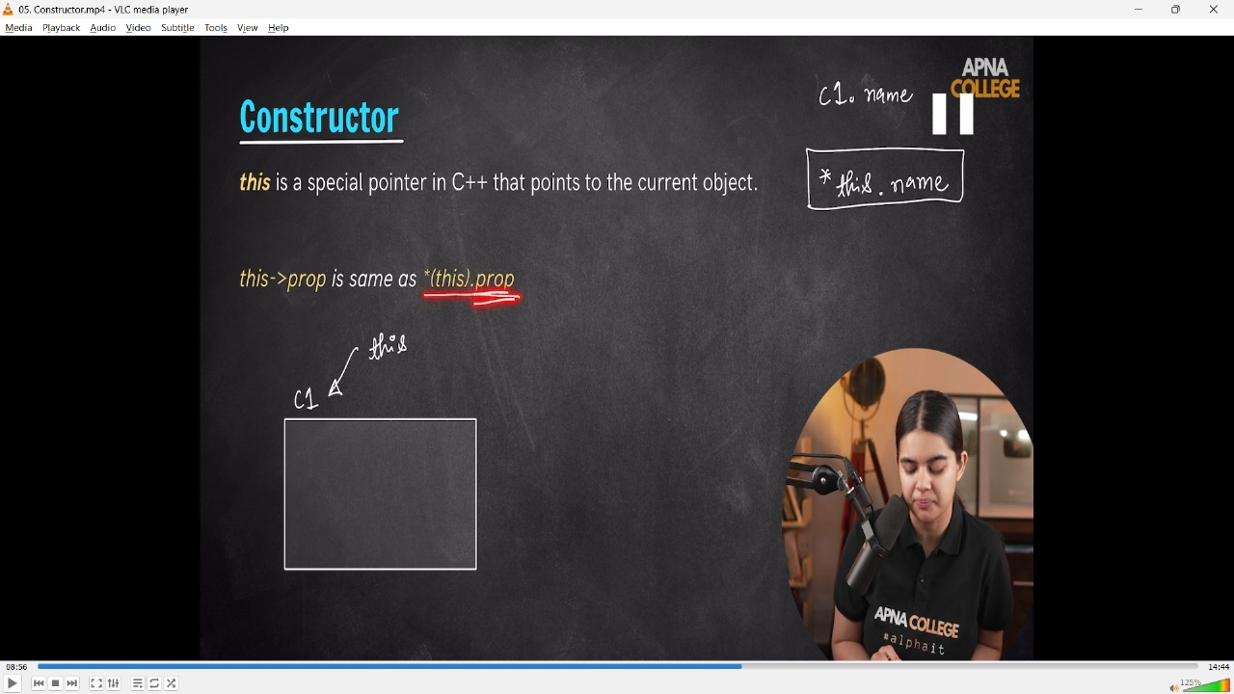

// This Constrcutor -this is a special pointer in c++ that points to the current object

// class Car1

// {

//     string name;

//     string color;

// public:

//     Car1(string name, string color)

//     {

//         cout << "Constructor is called. Object being created ..." << endl;

//         this->name = name;// phle waala name jo object bnaya uska h & dusra name jo fun me pass kiya uska he

//         this->color = color;

//     }

// };

// int main()

// {

//     Car1 c1("Altroz","Black");

// }

// -------------------

**//2.3) Types of Cosntrcutrs -**

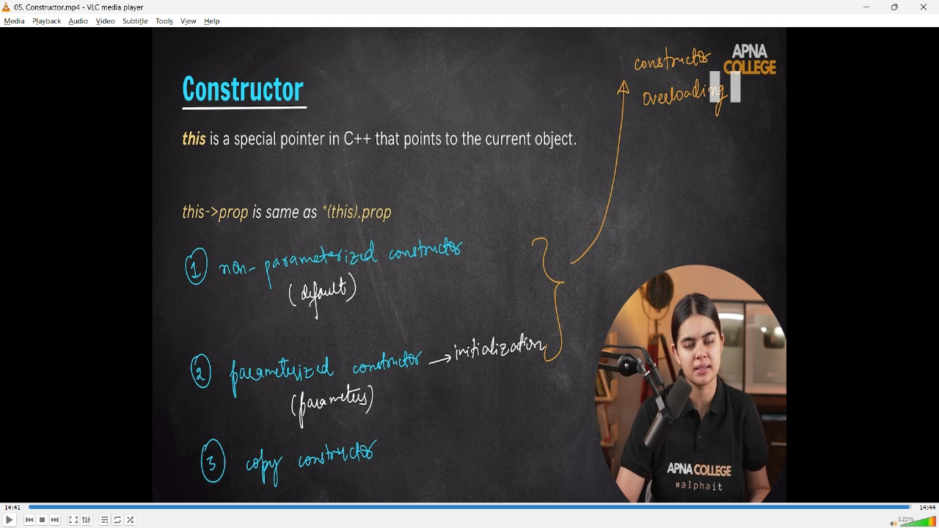

// class Car2

// {

//     string name;

//     string color;

// public:

//     Car2() // Non- Parameterized Constrcutor

//     {

//         cout << "Constructore w/o parameters " << endl;

//     }

//     Car2(string name, string color) // Parameteizewd constructor

//     {

//         cout << "Constructor with Parameters - " << endl;

//         this->name = name;

//         this->color = color;

//     }

//     // Getter

//     string getName()

//     {

//         return name;

//     }

// };

// int main()

// {   Car2 c0;//anyh object created for the class. this is non araterized constrcuot

//     Car2 c1("Altroz", "Black");

//     Car2 c2("Mahindra SUV AMT","Dark Blue");

// /*

// Constructore w/o parameters

// Constructor with Parameters -

// Constructor with Parameters -

//  */

// }

// -------------------

**Practice Qs**

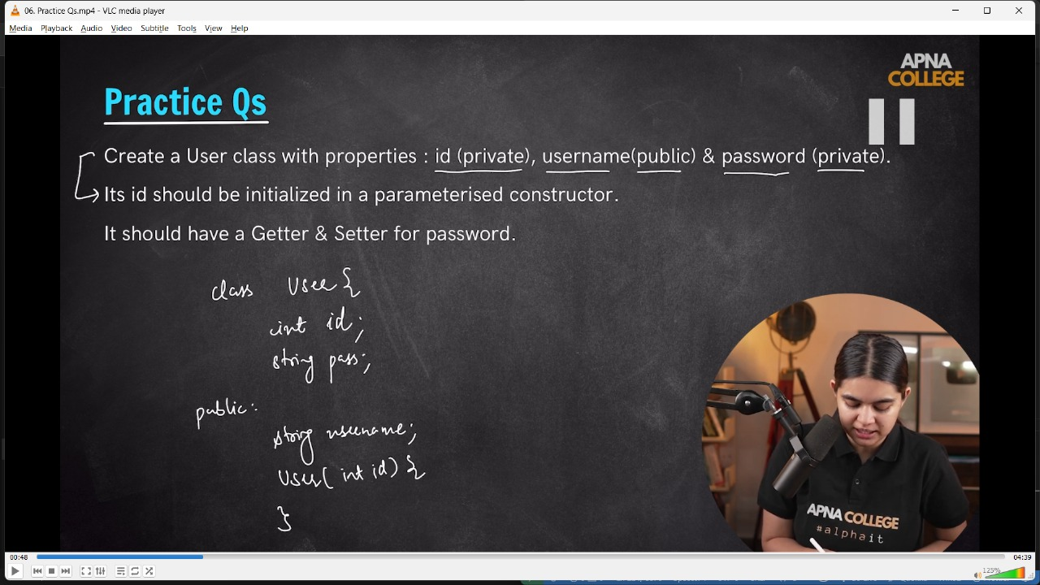

➡️ Create a User class with properties:

id (private), username (public) & password (private).

Its id should be initialized in a parameterized constructor.

It should have a Getter & Setter for password.

 */

// class User

// {

// private:

//     int id;

//     string password;

// public:

//     string username;

//     User(int id)

//     {

//         this->id = id; // this mean jo bhi current id h isme created parameter waali id ki value aa kr store ho jaaygi

//     }

//     // Getter

//     string getPassword()

//     {

//         return password;

//     }

//     // Setter

//     void setPassword(string password)

//     {

//         this->password = password;

//     }

// };

// int main()

// {

//     User user1(101);

//     user1.username = "MicrosftHyderabad";

//     user1.setPassword("Shubh@51LPA");

//     cout << "username : " << user1.username << endl;      // username : MicrosftHyderabad

//     cout << "password : " << user1.getPassword() << endl; // password : Shubh@51LPA

// }

// -------------------

**//2.4) Copy Constructor Conceppt -**

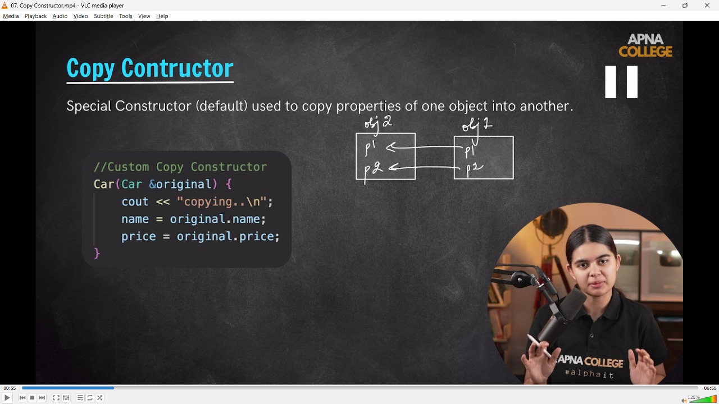

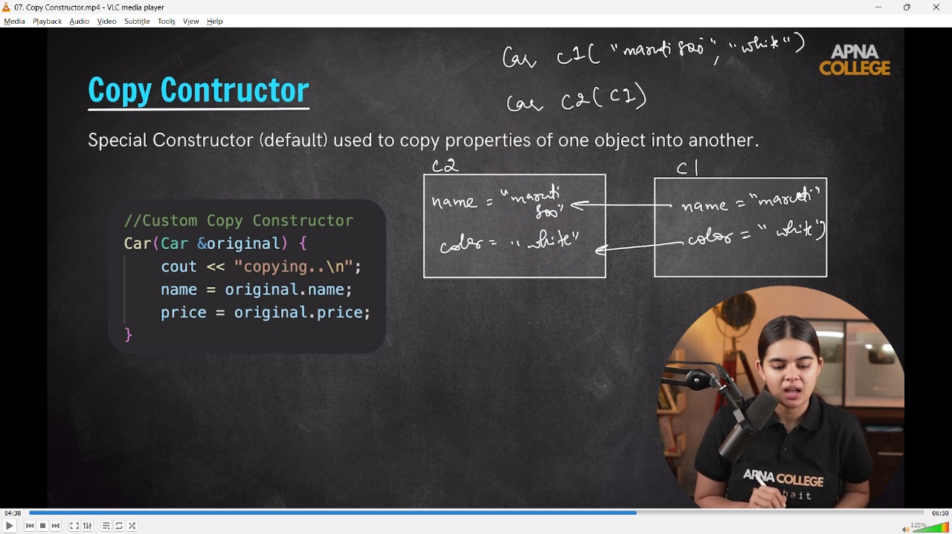

// class Car

// {

// public:

//     string name;

//     string color;

//     Car(string name, string color) // Parameteizewd constructor

//     {

//         this->name = name;

//         this->color = color;

//     }

//     Car(Car &original) // creating a copy constructor from the given original constrcuto at the same time

//     {

//         cout << "Copying original to new...." << endl;

//         name = original.name;

//         color = original.color;

//     }

// };

// int main()

// {

//     Car c1("Maninda SUV 700", "Dark Blue");

//     Car c2(c1);

//     cout << c2.name << endl;  // Maninda SUV 700

//     cout << c2.color << endl; // Dark Blue

//     // 📒 - by using the c1 we could access through c2. at where we passed c1/ So w/o creating a seperate cosntruuctor using c1 we could acess.

//     // Own custom copy constrcutor -

//     Car c3(c1);//Copying original to new....

//     cout << c3.name << endl;//Maninda SUV 700

//     cout << c3.color << endl;//Dark Blue

// }

// -------------------

**//2.5) Shallo & Deep Copy -**

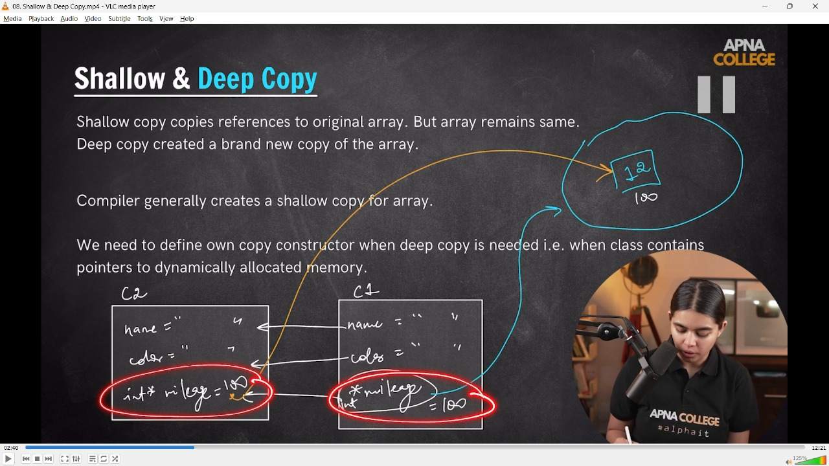

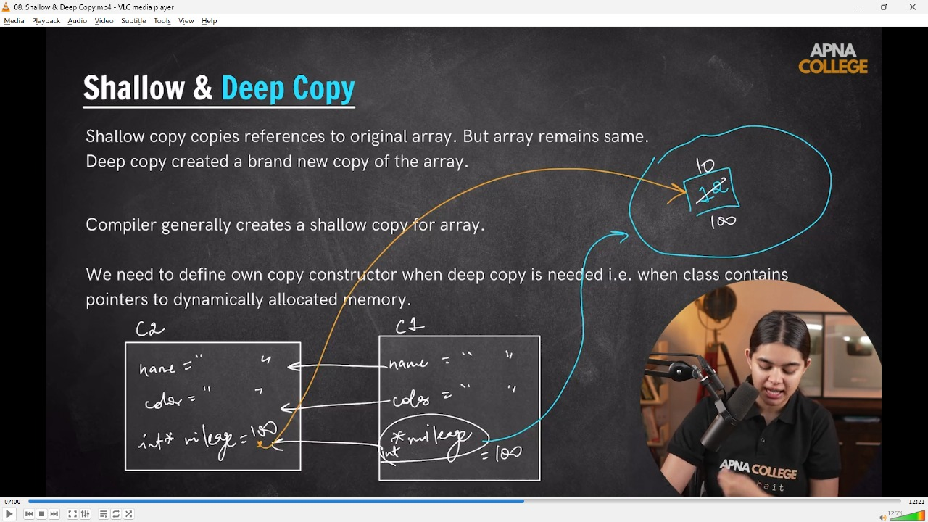

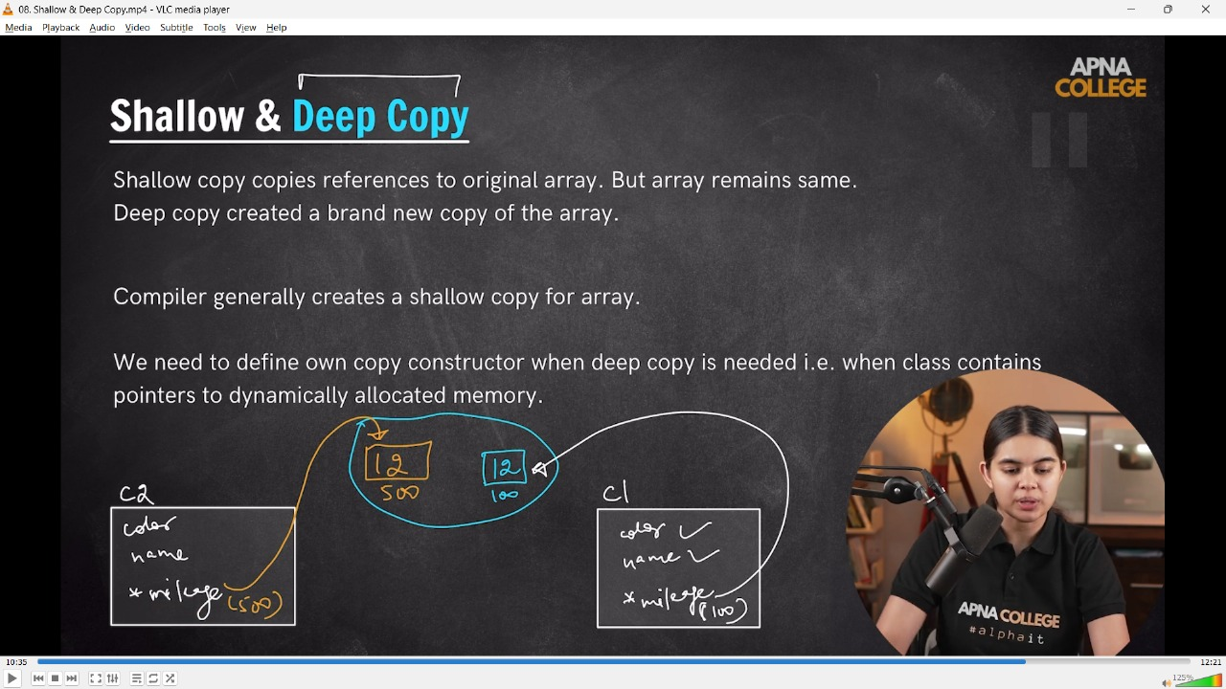

/*

📒 -copy constr. concept me saare statric var to  copy ho jaate h as it is from original memory

but dynamic constr. not copy while they orignaly copy from the heap memo and even on chaniging  in copies constrcutor the changes reflected in original constrctr adn heap emo. too

*/

// class Car

// {

// public:

//     string name;

//     string color;

//     int *mileage;

//     Car(string name, string color) // Parameteizewd constructor

//     {

//         this->name = name;

//         this->color = color;// These 2 are static allocation with proper copy from main meo

//         mileage = new int;// Dynamic Allocation - copy from heap memo on the behalf of addres & directly change in main and hap memo

//         *mileage = 12;

//     }

//     Car(Car &original) // creating a copy constructor from the given original constrcuto at the same time

//     {

//         cout << "Copying original to new...." << endl;

//         name = original.name;

//         color = original.color;

//         mileage = original.mileage;

//     }

// };

// int main()

// {

//     Car c1("Maninda SUV 700", "Dark Blue");

//    // Own custom copy constrcutor -

//     Car c3(c1);//Copying original to new....

//     cout << c3.name << endl;//Maninda SUV 700

//     cout << c3.color << endl;//Dark Blue

//     cout<<*c3.mileage<<endl;//12

//     *c3.mileage = 10;

//     cout<<*c1.mileage<<endl;///10 - so we did the xhange in c3 but also goit the change in c1 as in pointer or address also changges in main addres

// }

// -------------------

// what if i do changes in Original construcotr not the custom created constructor-

// class Car

// {

// public:

//     string name;

//     string color;

//     int *mileage;

//     Car(string name, string color) // Parameteizewd constructor

//     {

//         this->name = name;

//         this->color = color; // These 2 are static allocation with proper copy from main meo

//         mileage = new int;   // Dynamic Allocation - copy from heap memo on the behalf of addres & directly change in main and hap memo

//         *mileage = 12;

//     }

// };

// int main()

// {

//     Car c1("Maninda SUV 700", "Dark Blue");

//     // On changin in the main original ocnstr.

//     Car c2(c1);

//     cout << c2.name << endl;     // Maninda SUV 700

//     cout << c2.color << endl;    // Dark Blue

//     cout << *c2.mileage << endl; // 12

//     *c2.mileage = 10;

//     cout << *c1.mileage << endl; /// 10 - so we did the xhange in c2 which is in original constrr but also goit the change in c1 as in pointer or address also changges in main addres

// }

// -------------------

**//3) Destructor -**

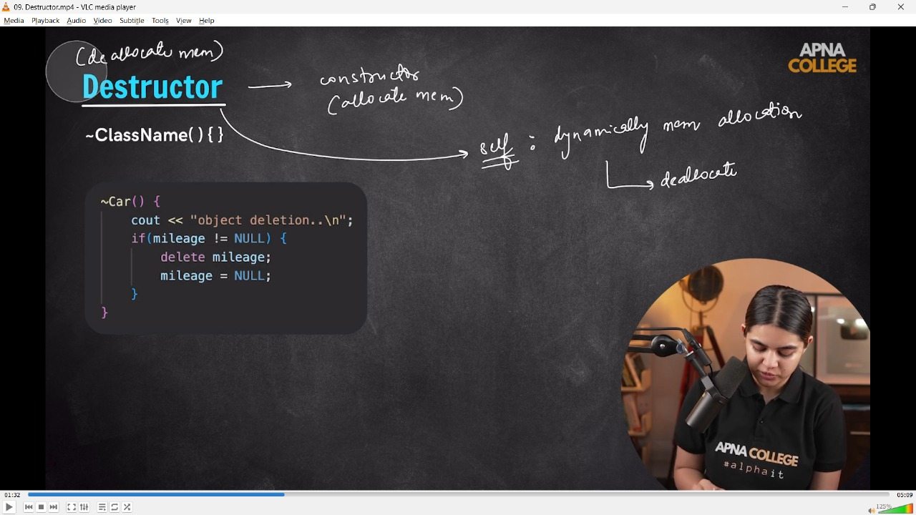

// Destructor  - It deletes the created constrcutors automaticqlly, bbut for custom constructores need to creatre destructor manually

// class Car

// {

// public:

//     string name;

//     string color;

//     int *mileage;

//     Car(string name, string color) // Parameteizewd constructor

//     {

//         this->name = name;

//         this->color = color; // These 2 are static allocation with proper copy from main meo

//         mileage = new int;   // Dynamic Allocation - copy from heap memo on the behalf of addres & directly change in main and hap memo

//         *mileage = 12;

//     }

//     ~Car()

//     {

//         cout << "Deletting Object - " << endl;

//     }

// };

// int main()

// {

//     Car c1("Maninda SUV 700", "Dark Blue");

//     cout << c1.name << endl;

//     cout << c1.color << endl;

//     cout << *c1.mileage << endl;

//     /*

//     Dark Blue

//     12

//     Deletting Object -

//      */

// }

// ____________ ____________ ____________ ____________ ____________

**4) Inheritance –**

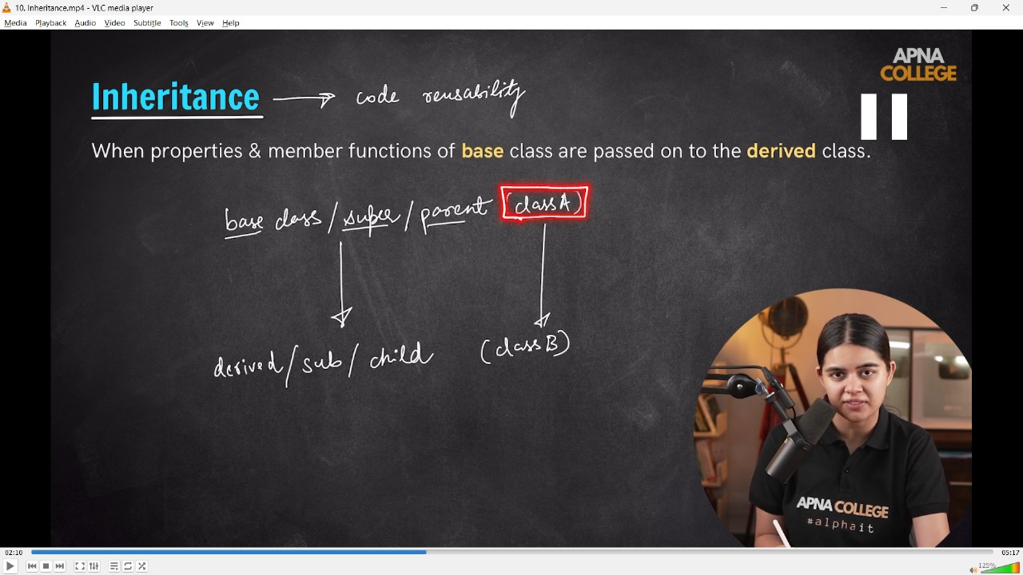

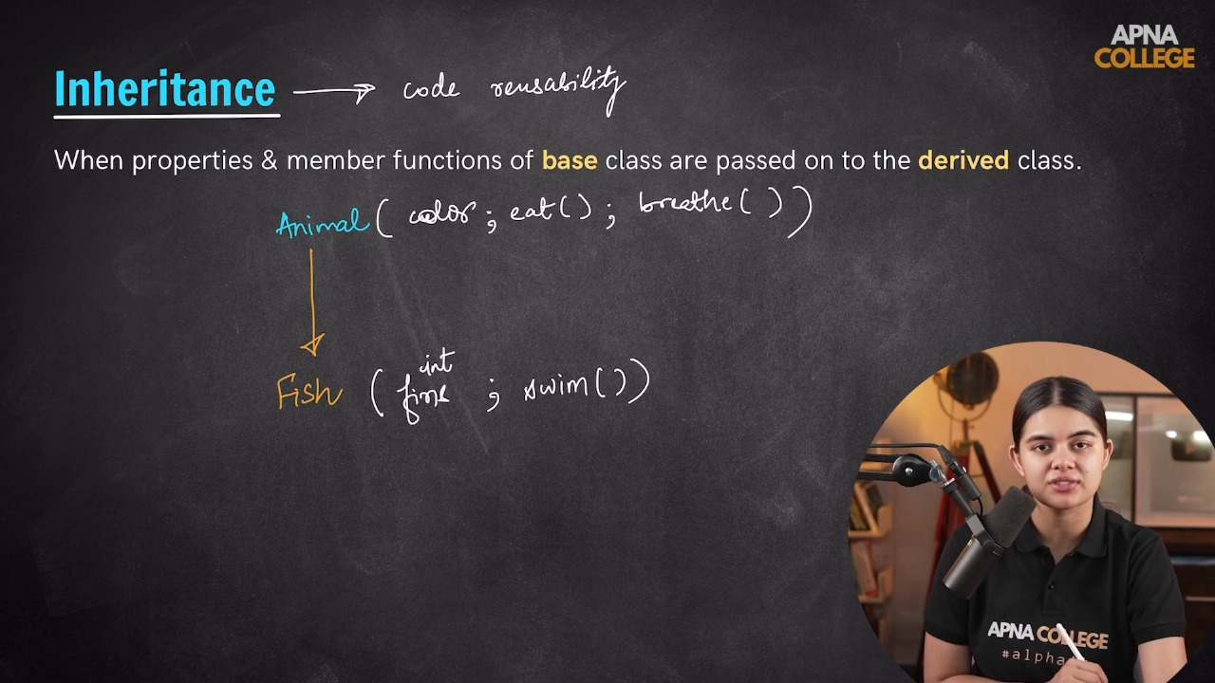

**// 4.1) Mode of Inheritance –**

**Case I**

**Case II**

**Case III**

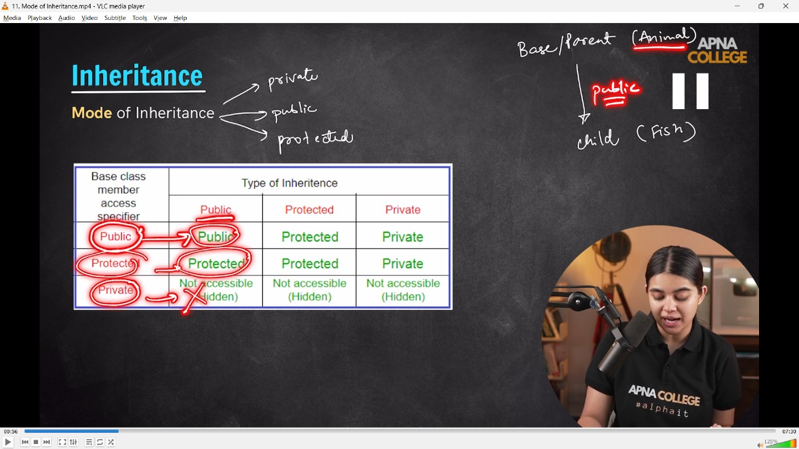

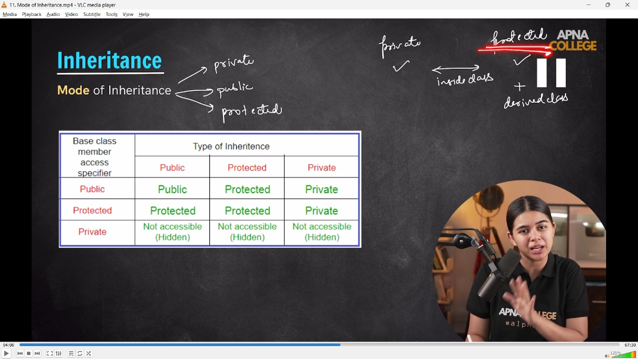

// Case - 1 - when both(parent & child class) are public

// class Animal

// {

// public:

//     string color;

//     void eat()

//     {

//         cout << "eats -" << endl;

//     }

//     void breathe()

//     {

//         cout << "breathes - " << endl;

//     }

// };

// class Fish : public Animal // Inheritance.

// {

// public:

//     int fins;

//     void swim()

//     {

//         cout << "swims - " << endl;

//     }

// };

// /*

// 📒 - In inheritance here is 2 classes alreaady defined eat and breathe,

// so the 3rd class forfish which also having these proertiesw and pne more property of swim which

// can be declare in this classs  and can be inherited from other class too.

// */

// int main()

// {

//     Fish f1;

//     f1.fins = 3;

//     cout << f1.fins << endl;

//     f1.swim();    // swims

//     f1.eat();     // eats

//     f1.breathe(); // breathes

//     /* So, how this 3rd class fish is able to access the elements of above 2 classes, by using Inheritance

//      */

// }

// -------------------

// What if I do the same for Protected class -

// Case - II - when parent class is public but the child class is protected -  can;tbe accessed by main fun

// class Animal

// {

// public:

//     string color;

//     void eat()

//     {

//         cout << "eats -" << endl;

//     }

//     void breathe()

//     {

//         cout << "breathes - " << endl;

//     }

// };

// class Fish2 : protected Animal // Inheritance.

// {

// public:

//     int fins2;

//     void swim2()

//     {

//         cout << "swims - " << endl;

//     }

// };

// int main()

// {

//     Fish2 f1;

//     f1.fins2 = 3;

//     cout << f1.fins2 << endl;

//     f1.swim2();   // swims

/* f1.eat();     // error: 'void Animal::breathe()' is inaccessible within this context

// f1.breathe(); // error: 'Animal' is not an accessible base of 'Fish2'

// SO clearly inacesible from main fun if class is protected , but can be acessed within the same class

*/

// }

// -------------------

// But within the calss, it can be accessible - inside the protected child class public parent clss can be accessed, not from main fun.

// class Animal

// {

// public:

//     string color;

//     void eat()

//     {

//         cout << "eats -" << endl;

//     }

//     void breathe()

//     {

//         cout << "breathes - " << endl;

//     }

// };

// class Fish2 : protected Animal // Inheritance.

// {

// public:

//     int fins2;

//     void swim2()

//     {

//         eat();

//         cout << "swims - " << endl;

//     }

// };

// int main()

// {

//     Fish2 f1;

//     f1.fins2 = 3;

//     cout << f1.fins2 << endl; // 3

//     f1.swim2();

//     /*

//     eats

//     swims

//     So, when the inside the protrcted class another classes are defined then can be accessed from main func

//      */

// }

// -------------------

// Case III - when the the parent class is by default Private & the child class is Public -

// class Animal

// {

// private:

//     string color;

//     void eat()

//     {

//         cout << "eats -" << endl;

//     }

//     void breathe()

//     {

//         cout << "breathes - " << endl;

//     }

// };

// class Fish2 : public Animal // Inheritance.

// {

// public:

//     int fins2;

//     void swim2()

//     {

//         // eat();

//         cout << "swims - " << endl;

//     }

// };

// int main()

// {

//     Fish2 f1;

//     f1.fins2 = 3;

//     cout << f1.fins2 << endl; // 3

//     f1.swim2();

// /* O/p -

// Inheritance.cpp: In member function 'void Fish2::swim2()':

// Inheritance.cpp:167:9: error: 'void Animal::eat()' is private within this context

//          eat();

//          ^~~

// Inheritance.cpp:149:10: note: declared private here

//      void eat()

//           ^~~

// Inheritance.cpp:167:13: error: 'void Animal::eat()' is private within this context

//          eat();

//              ^

// Inheritance.cpp:149:10: note: declared private here

//      void eat()

//           ^~~

// 📒 So, in the case where Parernt class is Pvt then not access to the child class either it's oublicor protected

//  */

// }

// ____________ ____________ ____________ ____________ ____________

**//4.2) types of Inheritance -**

**//4.2.1) Single Inheritance -**

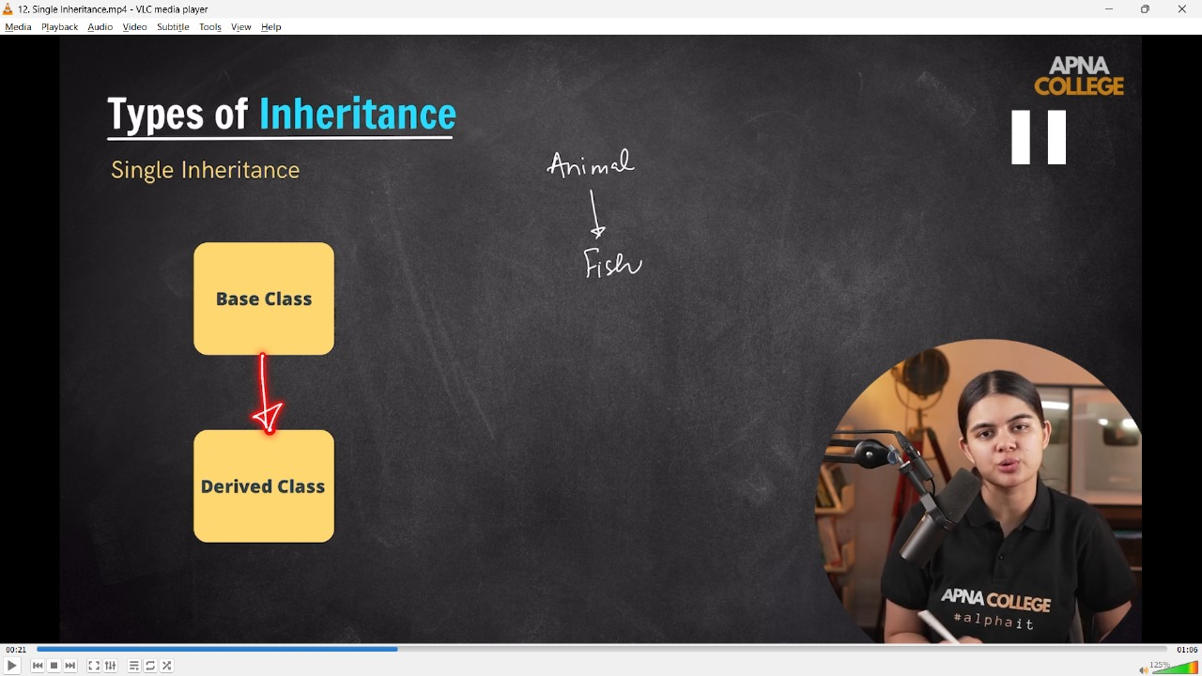

// class Animal

// {

// public:

//     string color;

//     void eat()

//     {

//         cout << "eats -" << endl;

//     }

//     void breathe()

//     {

//         cout << "breathes - " << endl;

//     }

// };

// class Fish : public Animal // Inheritance.

// {

// public:

//     int fins;

//     void swim()

//     {

//         cout << "swims - " << endl;

//     }

// };

// int main()

// {

//     Fish f1;

//     f1.swim();    // swims

//     f1.eat();     // eats

//     f1.breathe(); // breathes

// }

// ____________ ____________

**//4.2.2) Multi-Level Inheritance -**

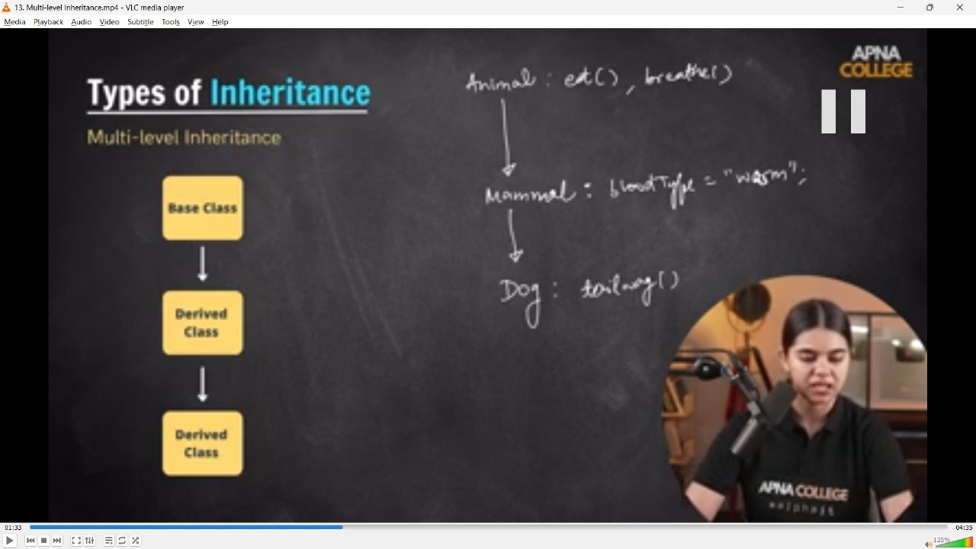

// class Animal

// {

// public:

//     void eats()

//     {

//         cout << "Eats..." << endl;

//     }

//     void breath()

//     {

//         cout << "Breaths..." << endl;

//     }

// };

// class Mammal : public Animal// Mammal class inherits all properties of Animal Class

// {

// public:

//     string bloodtype = "Warm";

//     // Or can also be called byh constructor -

//     string bloodcolor;

//     Mammal()

//     {

//         bloodcolor = "Greenish";

//     }

// };

// class Dog : public Mammal// while the dog class inherits all properties of Mammal class as well as Animal class too

// {

// public:

//     void tailmovement()

//     {

//         cout << "Dog can also wipe out its tail everytim,e" << endl;

//     }

// };

// int main()

// {

//     Dog d1;

//     d1.eats();

//     d1.breath();

//     d1.tailmovement();

//     cout << "So, the colour of blood is - " << d1.bloodcolor << endl;

// /*

// Eats...

// Breaths...

// Dog can also wipe out its tail everytim,e

// So, the colour of blood is - Greenish

// */

// }

// ____________ ____________

**//4.2.3) Multiple Inheritance -**

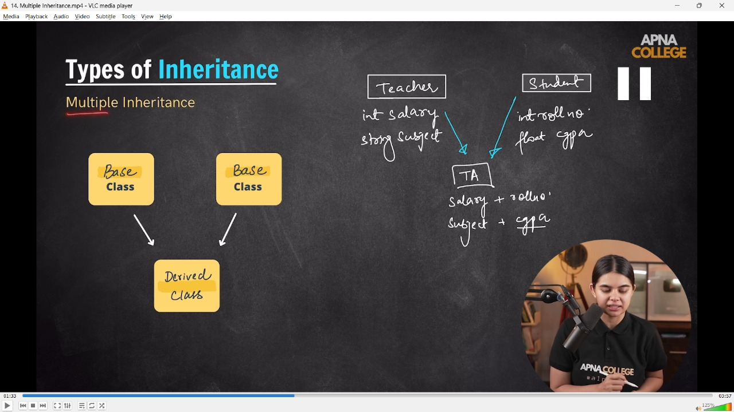

// class Teacher

// {

// public:

//     int salary;

//     string subject;

// };

// class Student

// {

// public:

//     long rollno;

//     float cgpa;

// };

// class TA : public Teacher, public Student

// {

// public:

//     string name;

// };

// int main()

// {

//     TA ta1;

//     ta1.name = "Shubham Mahajan";

//     ta1.subject = "C++";

//     ta1.rollno = 4088;

//     ta1.cgpa = 7.5;

//     cout << ta1.name << endl;//Shubham Mahajan

//     cout << ta1.cgpa << endl;//7.5

//     cout << ta1.subject << endl;//C++

//     cout << ta1.rollno << endl;//4088

// }

// ____________ ____________

**//4.2.4) Hierarchical Inheritance -**

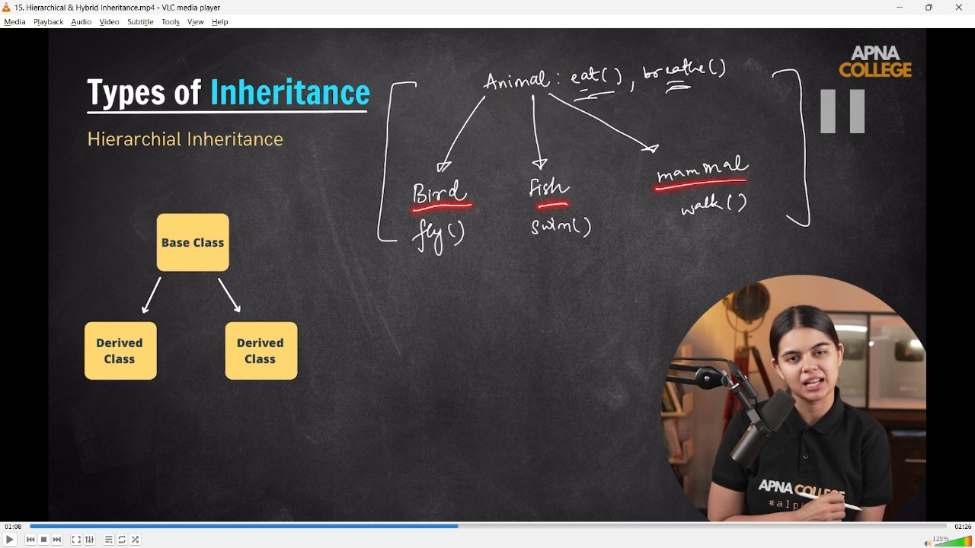

// class Animal

// {

// public:

//     void Eat()

//     {

//         cout << "Can eat easily" << endl;

//     }

//     void Breathe()

//     {

//         cout << "Breathing as a regular process.." << endl;

//     }

// };

// class Bird : public Animal

// {

// public:

//     void fly()

//     {

//         cout << "Can fly too.." << endl;

//     }

// };

// class Fish : public Animal

// {

// public:

//     void swim()

//     {

//         cout << "Can swim in water..." << endl;

//     }

// };

// class Mammal : public Animal

// {

// public:

//     void walk()

//     {

//         cout << "Can also walk regularly.." << endl;

//     }

// };

// int main()

// {

//     Mammal m1;

//     m1.Breathe();//Breathing as a regular process..

//     m1.Eat();//Can eat easily

//     m1.walk();//Can also walk regularly..

//     cout << endl;

//     Bird b1;

//     b1.Eat();//Can eat easily

//     b1.Breathe();//Breathing as a regular process..

//     b1.fly();//Can fly too..

//     cout << endl;

//     Fish f1;

//     f1.Breathe();//Breathing as a regular process..

//     f1.swim();//Can swim in water...

//     return 0;

// // So, the clearly visible example of Hierarchical Inheritacne wheather multiple derived classeds from the one base class

// }

// ____________ ____________

**//4.2.5) Hybrid Inheroitance -**

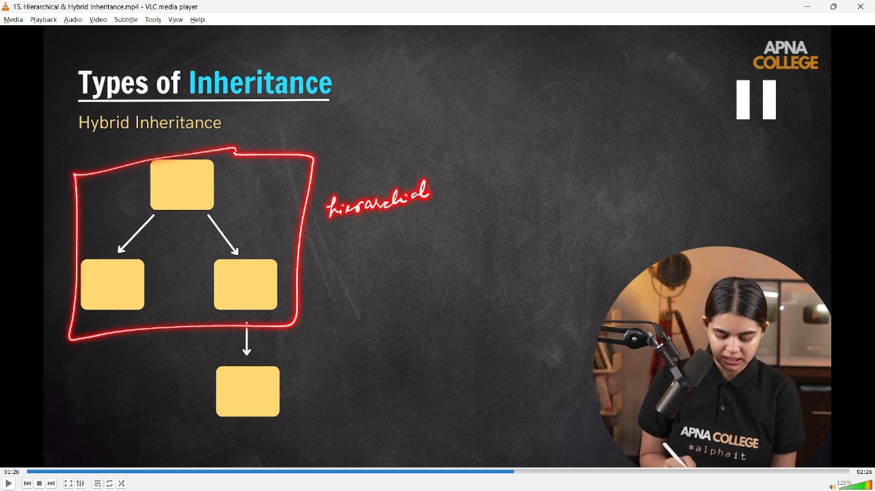

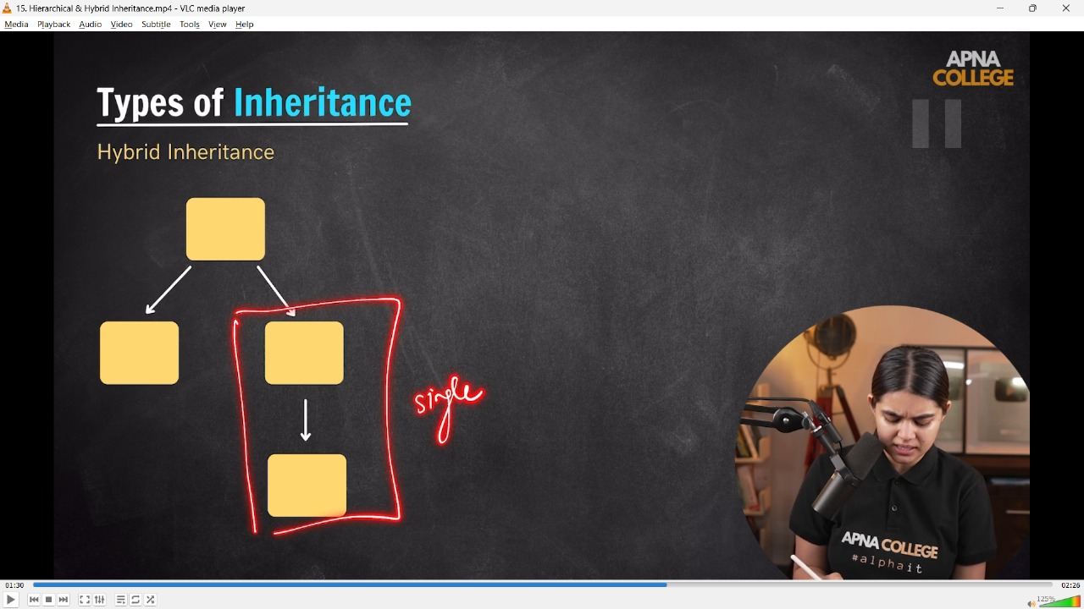

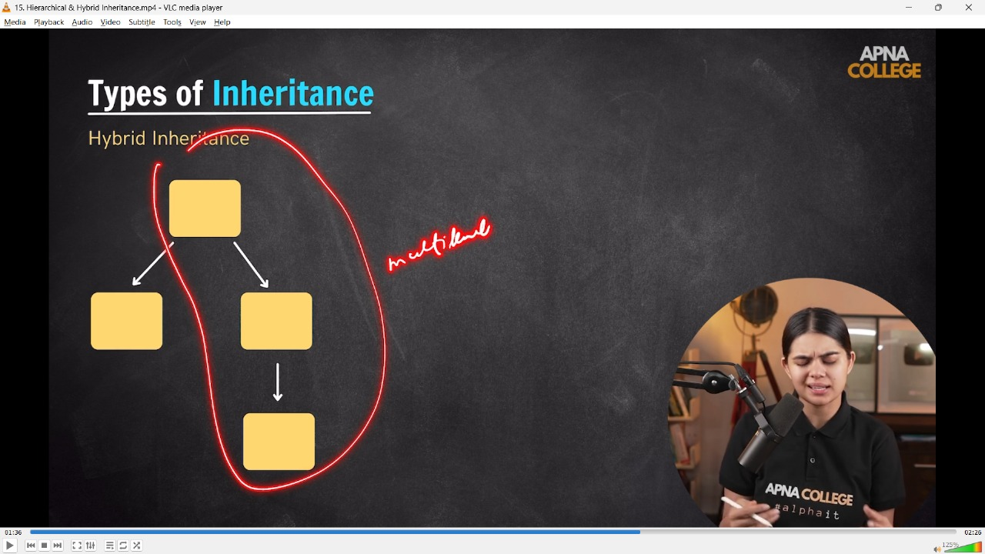

// class Animal

// {

// public:

//     void Eat()

//     {

//         cout << "Can eat easily" << endl;

//     }

//     void Breathe()

//     {

//         cout << "Breathing as a regular process.." << endl;

//     }

// };

// class Fish : public Animal

// {

// public:

//     void swim()

//     {

//         cout << "Can swim in water..." << endl;

//     }

// };

// class Turtle : public Fish

// {

// public:

//     void walkAndSwim()

//     {

//         cout << "Can also walk as well as swim too.." << endl;

//     }

// };

// class Bird : public Animal

// {

// public:

//     void fly()

//     {

//         cout << "Can fly too.." << endl;

//     }

// };

// int main()

// {

//     Turtle t1;

//     t1.Breathe();//Breathing as a regular process..

//     t1.Eat();//Can eat easily

//     t1.swim();//Can swim in water...

//     t1.walkAndSwim();//Can also walk as well as swim too..

// /*  📒 -  so clearly its an example if Hybrid Inheritance(as the combonatoin of more tha one inheritance) wheather -

// Single Imheritace - Class Fish is derived from Class Animal -

// Multi Level Inheritance - Class Turtle is derivedf from class fish which is further derived from Animal class

// Hierarchical Inheritance - Class Bird is aslo derived from the class Animal

//  */

// }

// ____________ ____________ ____________ ____________ ____________

**//5) Polymorphism -**

**//5.1) Compiletime Polymorphism**

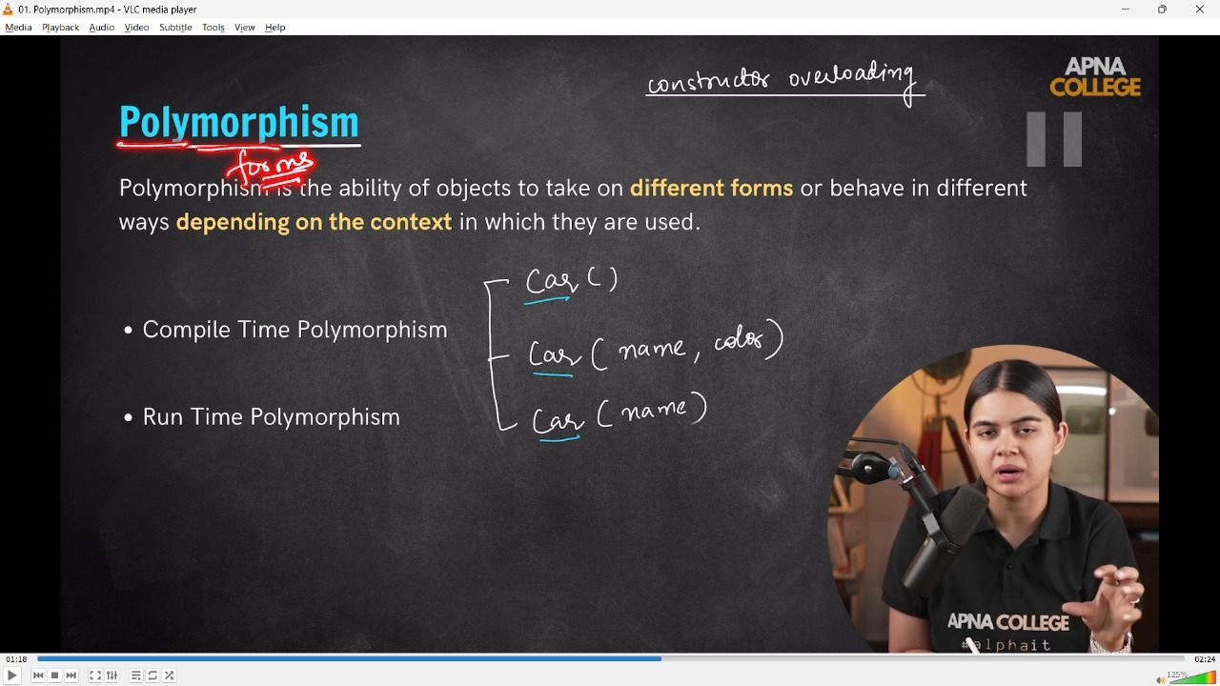

**5.1.1) Function Overloading**

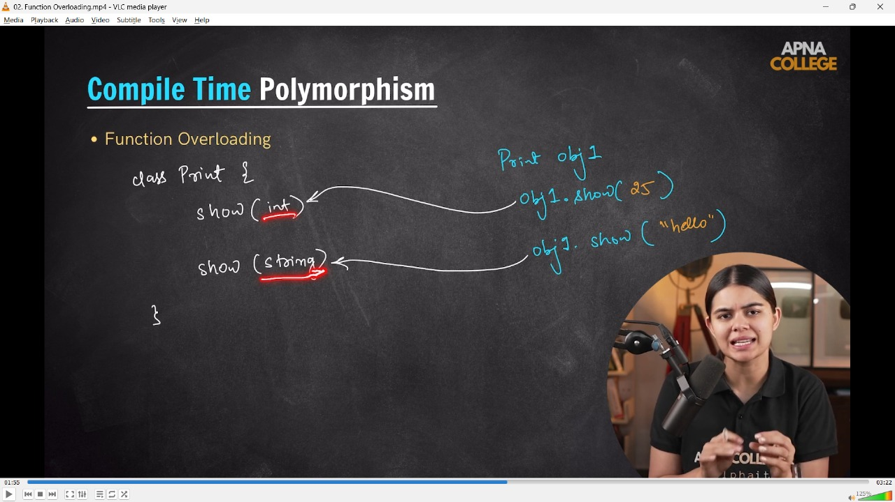

//5.1.1) Function Overloading  - where same name fun with diff. arguements with different values

// class Print

// {

//     public:

//     void show(int x)

//     {

//         cout<<"int : "<<x<<endl;

//     }

//     void show(string str)

//     {

//         cout<<"string : "<<str<<endl;

//     }

// };

// int main()

// {

//     Print obj1;

//     obj1.show(51);//int : 51

//     obj1.show("ApnaCollege");//string : ApnaCollege

//     /*  So when we called the fun then int waale fun me int value pass huyi & string waale fun me string waali val

//         So, in such a way in Function Overloading Compile TIme Polymor[hism is called]

//     */

// }

**//5.1.2) Function Overloading  -**

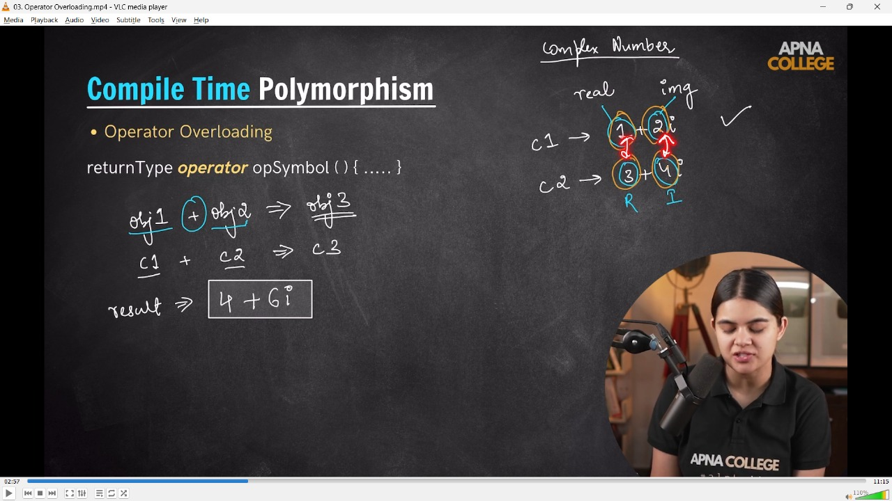

/*

Oeprator Overloading - so as we've seen that - in constructor with the same name & diff. parameters - its called COnstrcutor Overloading

When same named function with different arguments are known as Function Overloadig

So similarly when sme operator but works differetn is called Operator Overloading

 */

// class Complex

// {

//     int real;

//     int img;

// public:

//     Complex(int r, int i)

//     {

//         real = r;

//         img = i;

//     }

//     void ShowNum()

//     {

//         cout << real << "+" << img << "i" << endl;

//     }

//     void operator + (Complex &c2)// Operator Overloading

//     {

//         int resReal = this-> real + c2.real;

//         int resImg = this->img + c2.img;

//         Complex c3(resReal, resImg);

//         c3.ShowNum();

//     }

//     void operator - (Complex &c2)// Operator Overloading

//     {

//         int resReal = this-> real - c2.real;

//         int resImg = this->img - c2.img;

//         Complex c3(resReal, resImg);

//         c3.ShowNum();

//     }

// };

// int main()

// {

//     Complex c1(1, 2);

//     Complex c2(3, 4);

//     c1.ShowNum();//1+2i

//     c2.ShowNum();//3+4i

//     c1+c2;//4+6i

//     c1-c2;//-2+-2i

// }

// ____________ ____________ ____________ ____________ ____________

**//5.2)Polymorphism -**

**//5.2.1)Function Overriding  -**

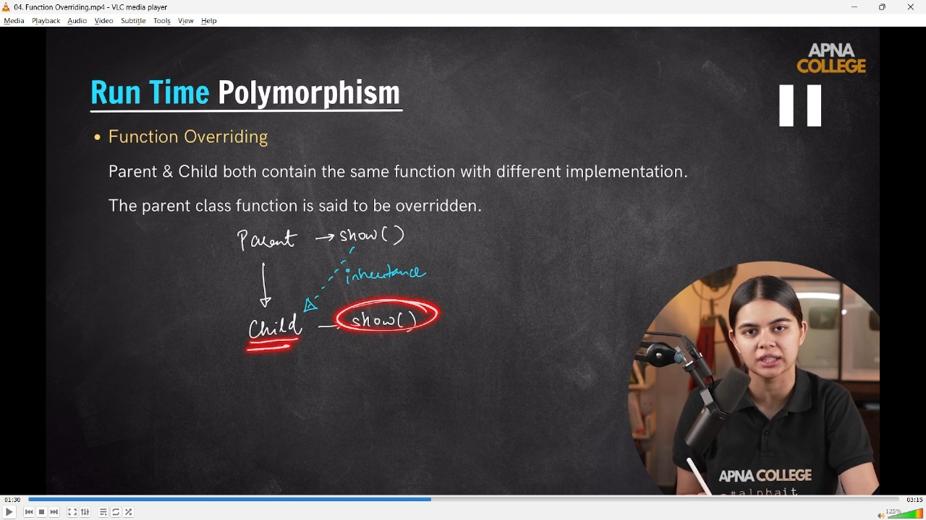

//5.2.1)Function Overriding  - when parent & child both contain the same fun wit differrent implementation. Parent & child dono classses me same fun h but diff datatypes ke liye diff implementations he , this is Function Overriding.

// class Parent

// {

// public:

//     void show()

//     {

//         cout << "Parent Class Show Function.." << endl;

//     }

// };

// class Child : public Parent

// {

// public:

//     void show()

//     {

//         cout << "Chil CLass Show Function .." << endl;

//     }

// };

// int main()

// {

//     Child child1;//Created Object of child class

//     child1.show();//Chil CLass Show Function ..

// /* Overloading me ek hi class ke under dono fun ka name same hota h jabki

// OverRiding me ek calss inherited hoti h or usme fun ka name same hota he

//  */

// }

// -------------------

**//5.2.2)Virtual Functions -**

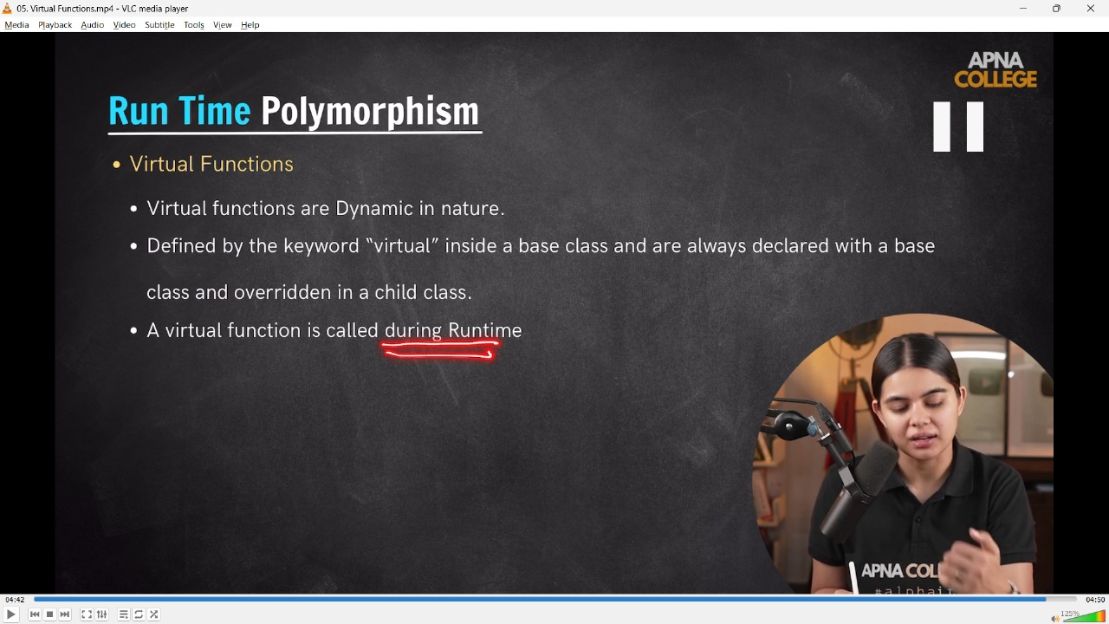

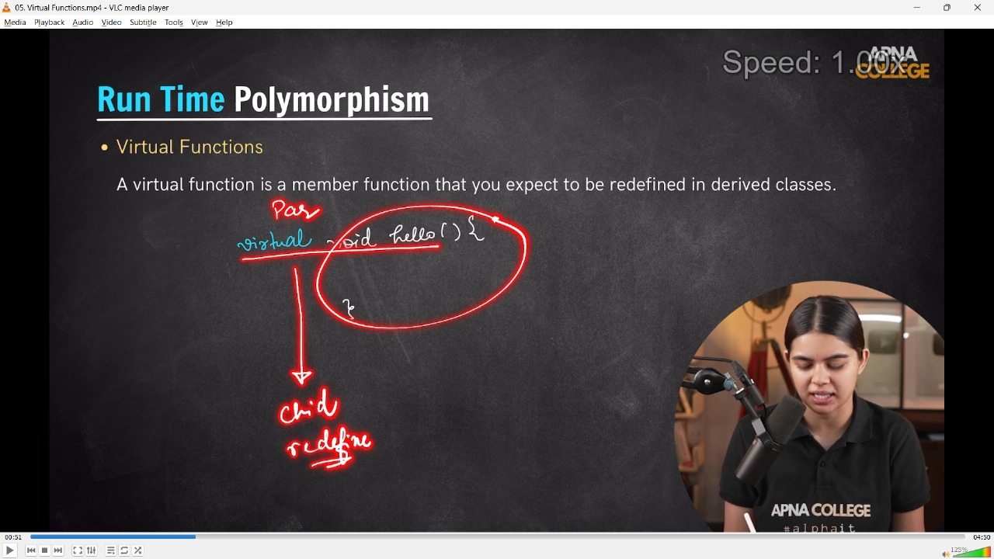

// class Parent

// {

// public:

//     virtual void hello()

//     {

//         cout << "parent Hello " << endl;

//     }

// };

// class Child : public Parent

// {

// public:

//     void hello()

//     {

//         cout << "Child classs hello --" << endl;

//     }

// };

// int main()

// {

//     Child child1;//child class ka oonject bnaya he

//     Parent *ptr; // Parent class k liye pointer define kiya he

//     ptr = &child1; // run time waali bindng - Parent class ke pointer ko child class me point kra rhe h

//     ptr->hello();//Child classs hello -- parent class ke pointer se child class ke hello fun ko call kra]tya

//     // Child Func>>Inheritance

// }

// ____________ ____________ ____________ ____________ ____________

**6) Abstraction –**

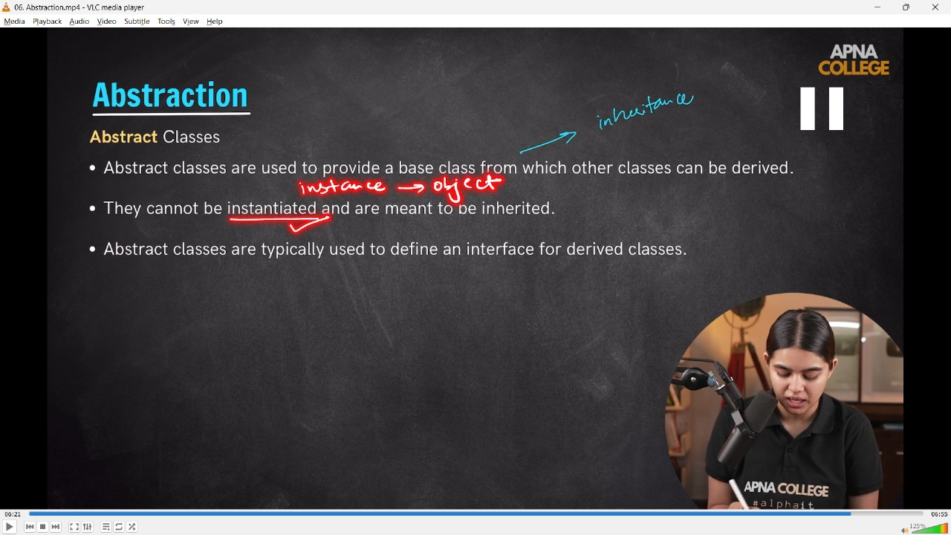

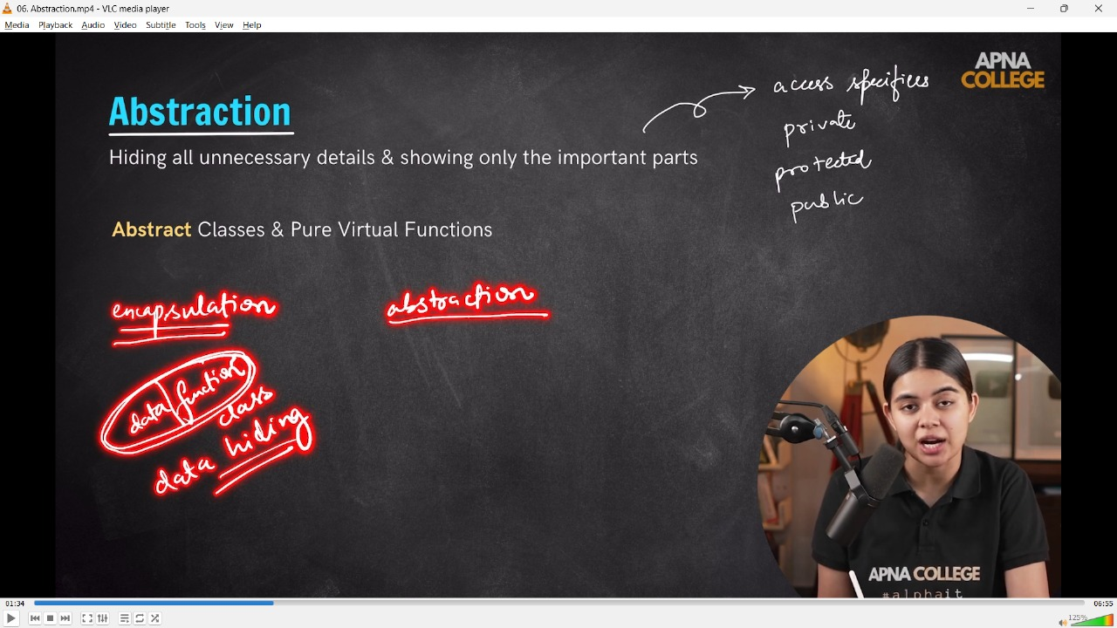

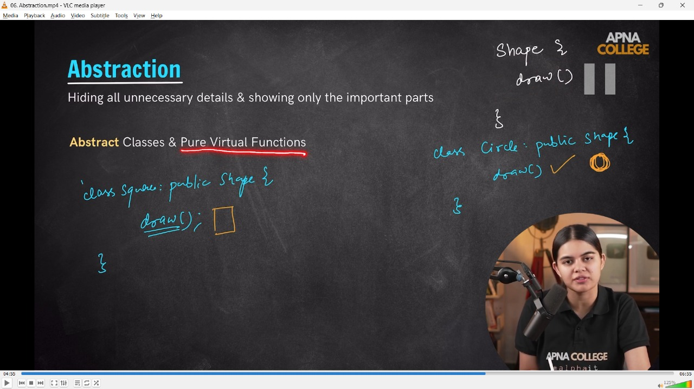

//6) Abstraction - Hiding all unnecessary details & sbhowing only the important parts

/* Access Mofdifer is a way which defined to abstraction. Because for unnecessary detai it can be hide through PRIVATE & PROTECTED while necessary details can be shown through PUBLIC

 */

//6.1) Pure Virtual Function -

// class Shape

// {

// public:

//     virtual void draw() = 0; // Pure virtual function - enforces derived classes to implement draw()

// };

// class Circle : public Shape

// {

// public:

//     void draw() override

//     {

//         cout << "Draw Circle -" << endl;

//     }

// };

// class Square : public Shape

// {

// public:

//     void draw() override

//     {

//         cout << "Draw Square -" << endl;

//     }

// };

// int main()

// {

//     Circle cir1;

//     cir1.draw();

//     Square squ1;

//     squ1.draw();

//     return 0;

// }

// ____________ ____________ ____________ ____________ ____________

**7) Static Keyword –**

**// 1) For funcitons -**

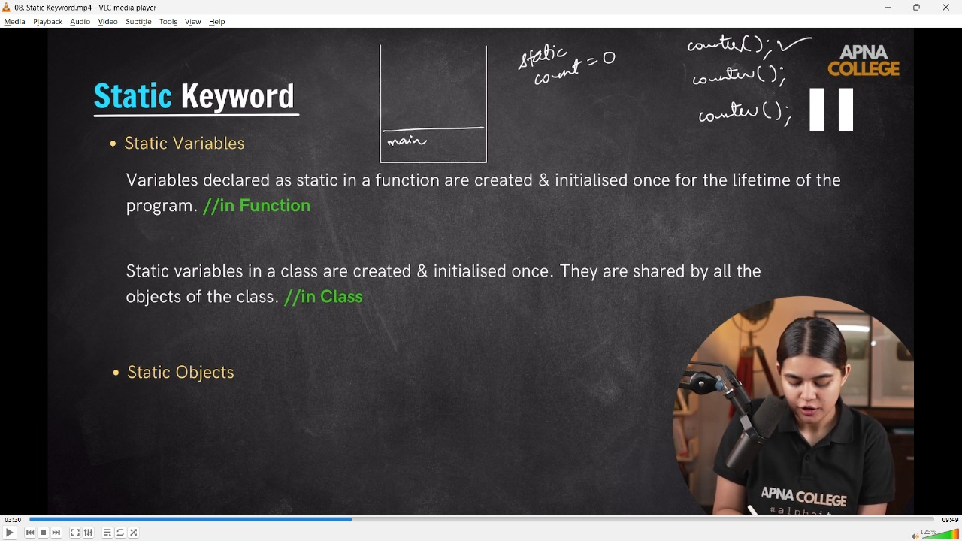

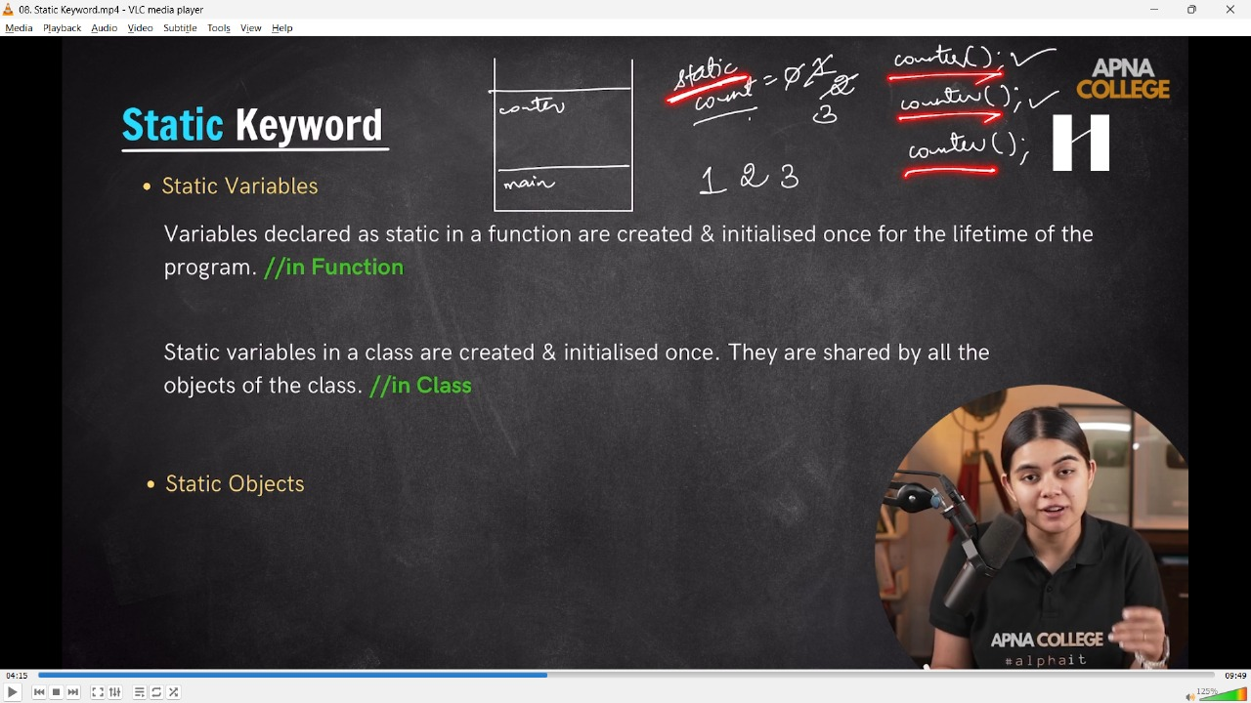

// void Counter()

// {

//     int count = 0;

//     count++;

//     cout << "Count is : " << count << endl;

// };

// int main()

// {

//     Counter(); // Count is : 1

//     Counter(); // Count is : 1

//     Counter(); // Count is : 1

//     /* here w/o declaring static keyowrd in nthe function, the count variable created again and again 3 times in the memory, but when we use static fun then the variable only creates once and updates value

//      */

// }

// void Counter()

// {

//     static int count = 0;

//     count++;

//     cout<<"Count is : "<<count<<endl;

// };

// int main()

// {

//     Counter();//Count is : 1

//     Counter();//Count is : 2

//     Counter();//Count is : 3

// }

// ____________ ____________

**// 2) For class**

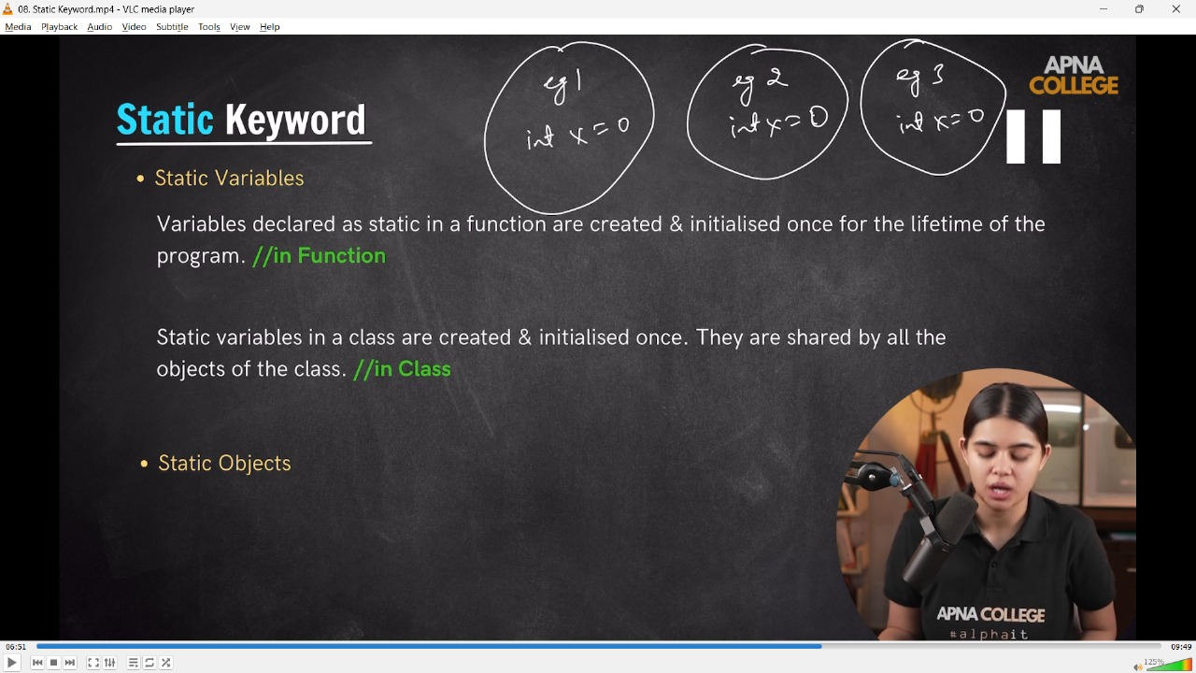

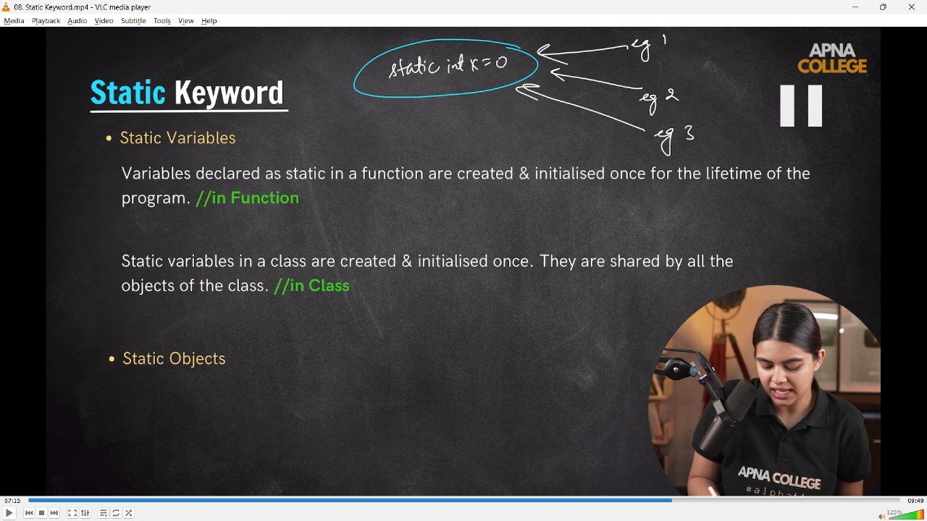

// class Example

// {

// public:

//     int x = 0;

// };

// int main()

// {

//     Example eg1;

//     Example eg2;

//     Example eg3;

//     cout << eg1.x++ << endl; // 0

//     cout << eg2.x++ << endl; // 0

//     cout << eg3.x++ << endl; // 0

// }

// when we use static keyword for the class then it is created for all the objects assignes witht the same class

// when we use static keyword for the class, then for it need to done the declaration(::) of variable witht he class

// class Example

// {

// public:

//     static int x;

// };

// int Example::x = 0; // declaration of x in the example class

// int main()

// {

//     Example eg1;

//     Example eg2;

//     Example eg3;

//     cout << eg1.x++ << endl; // 0

//     cout << eg2.x++ << endl; // 1

//     cout << eg3.x++ << endl; // 2

// }

// ____________ ____________

**// 3) For obejcts  - Stattic keyword is for lifetime**

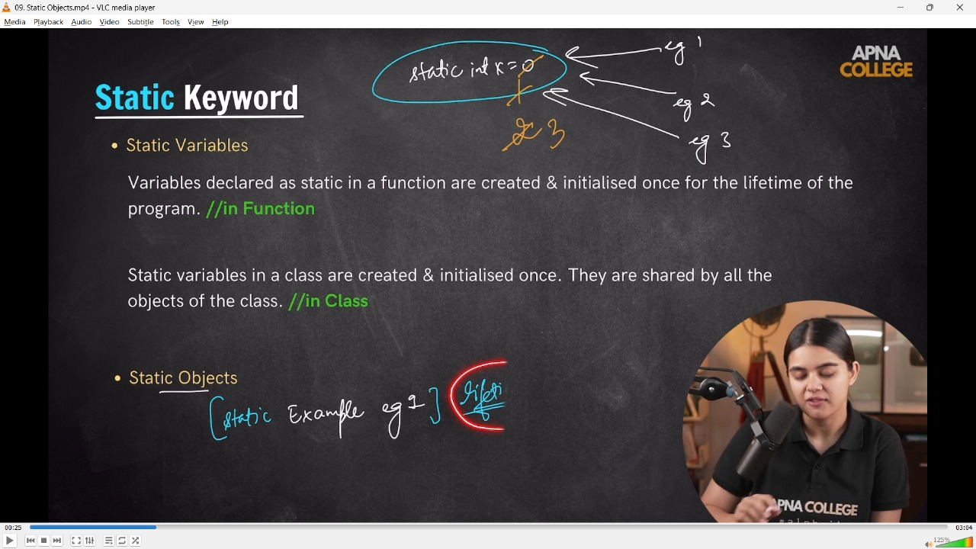

// class Example

// {

// public:

//     Example()

//     {

//         cout << "Constructor - " << endl;

//     }

//     ~Example()

//     {

//         cout << "Destructor - " << endl;

//     }

// };

// int main()

// {

//     int a = 0;

//     if (a == 0)

//     {

//          Example eg1;

//     }

//     cout << "Code Ending - " << endl;

// /*

// Constructor -

// Destructor -

// Code Ending -

// Bt what happens when we use static keyword-

//  */

//     if (a == 0)

//     {

//         static Example eg1;

//     }

//     cout << "Code Ending - " << endl;

// /*

// Constructor -

// Destructor -

// Code Ending -

//  */

// }

// ____________ ____________

**8) Friend Class & Friend Function –**

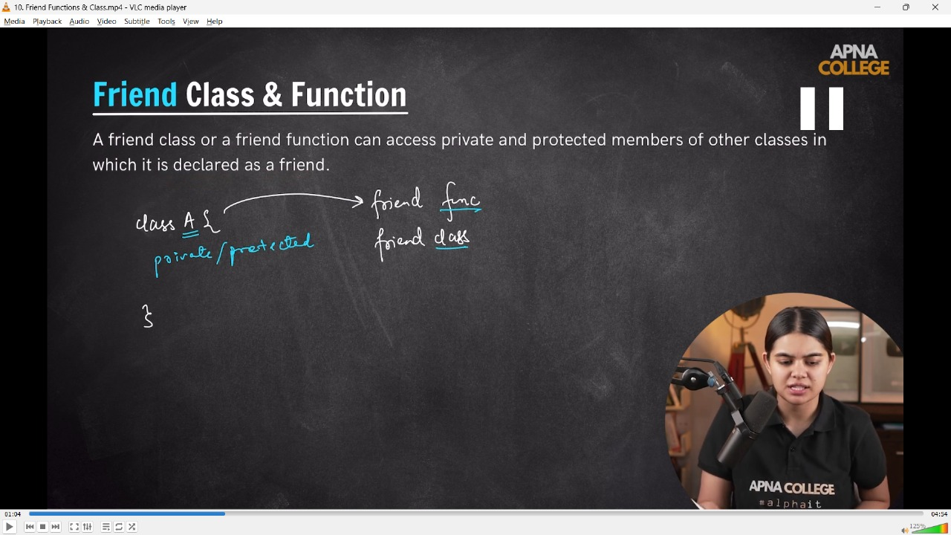

//7) Friend Class & Friend Function - A friend who has over ovt info can be reveal outside

// class A

// {

//     string secret = "Personal Data";

// };

// class B

// {

//     public:

//     void showSecret(A &obj)

//     {

//         // cout<<obj.secret<<endl;

//     }

//     // error: 'std::__cxx11::string A::secret' is private within this context

//     // this is invalid and showing error, not accesible to priovate class's data

//     // So, for avoiding this we can do ki B class ko class A ka friend bna diya

// // };

// int main()

// {

//     A a1;

//     B b1;

//     b1.showSecret(a1);

// }

// -------------------

// class A

// {

//     string secret = "Personal Data";

//     friend class B;// cslss b has been become friend for class A

// };

// class B

// {

// public:

//     void showSecret(A &obj)

//     {

//         cout << obj.secret << endl;//Personal Data

//     }

// };

// int main()

// {

//     A a1;

//     B b1;

//     b1.showSecret(a1);

// }

// ____________ ____________ ____________ ____________ ____________

**// Practice Q'S -**

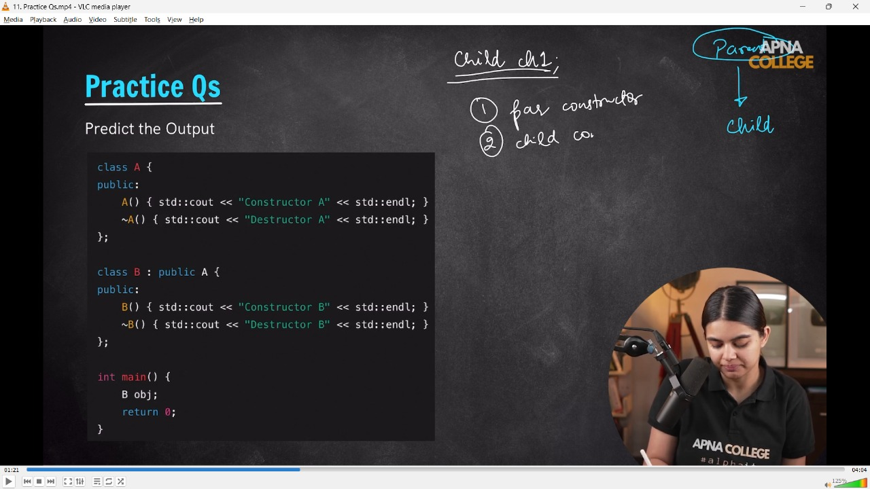

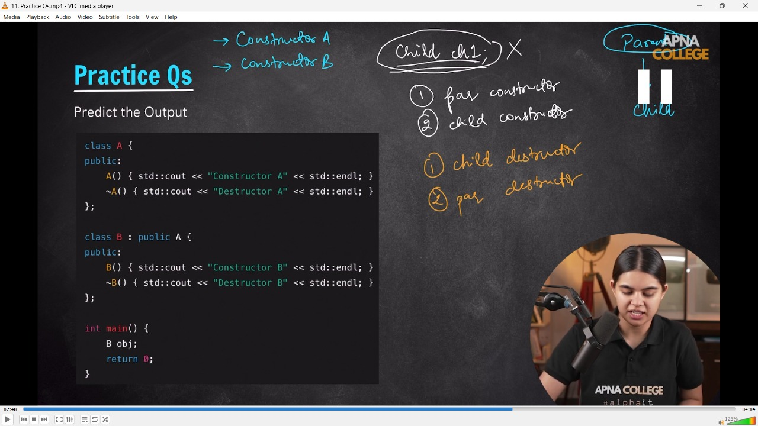

/*

Predict the Output

class A {

public:

    A() { std: : cout << "Constructor A" << std: :endl; }

    ~A() { std :: cout << "Destructor A" << std :: endl; }

};

class B : public A {

public:

    B() { std: : cout << "Constructor B" << std: :endl; }

    ~B() { std :: cout << "Destructor B" << std: :endl; }

};

int main() {

B obj;

return 0;

}

 */

// class Parent

// {

// public:

//     Parent()

//     {

//         cout << "Constructor Parent Class " << endl;

//     }

//     ~Parent()

//     {

//         cout << "Dectructor Parent Class " << endl;

//     }

// };

// class Child : public Parent

// {

// public:

//     Child()

//     {

//         cout << "Constructor Child CLass " << endl;

//     }

//     ~Child()

//     {

//         cout << "Dectructor Child CLass " << endl;

//     }

// };

// int main()

// {

//     Child ch1; // Object of child class, first call always go to Parent Class Contructor then it calls to Child Class COnstructor

//     /* O/p -

//     Constructor Parent Class

//     Constructor Child CLass

//      */

//     /* O/p - // In case if Desctructor, first call always go to Child Class Destructor then it calls to Parent Class Constructor

//     Dectructor Child CLass

//     Dectructor Parent Class

//      */

//     /*

//     📒 - So order for constructor & disctructor calling for parent & Child Classes

//     i) Constructor of Parent Class

//     ii) Constructor of Child Class

//     iii) Dewstructor of Parent Class

//     iv) Dewstructor of Child Class

//      */

// }

**//Qun – 2 : -**



           